2.1 I can plan using suitable project management techniques

When planning to create my website it was essential for me to choose a project management tool to keep track of the tasks required for completion .This would help ensure that the project is completed in a timely and organised manner. I chose to use a Gantt chart to breakdown the tasks required to develop my website as below;

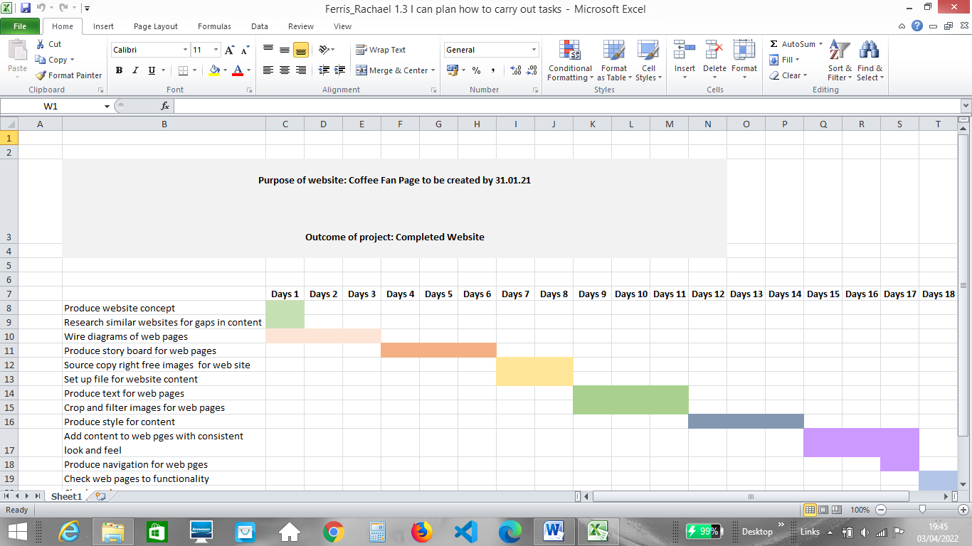

The above Gantt chart acts as a visual outline of my product backlog (tasks that need to be completed), breaking down the overall project down into individual tasks. Each task can be given a scheduled timeline for completion as tasks can be given allocated timeframes as well as be assigned dependencies e.g. finish to start tasks (Task B can only start when Task A is finished).

Setting up a Kanban board on Trello has allowed me to set up a plan of work that I will aim to complete during a specific ‘sprint’. I can prioritise tasks from my product backlog and assign them to a To Do category for completion during the sprint timeframe e.g. tasks to be completed over a two week sprint. I can factor in my personal WIP limits (work in progress limit) as well as buffer time to allow for any issues that may arise e.g. more time for research and schedule an estimated workload that can be completed in the timeframe. Tasks not completed within the sprint are rolled over into the next sprint for completion. Kanban is an agile form of project methodology designed to streamline work flow which helps me to easily see what is in progress and focus on one task at time rather than try to multitask and have numerous unfinished tasks.

I have set up my Kanban board with the following categories;

* **To Do – My product backlog**
* **In Progress – Tasks currently being worked on**
* **Blocked/ On hold – Items that are blocked from progressing**
* **Done – Tasks completed and ready for verification**